1. **AFG_AMB_FIX_FXGO:**
   1. Download AFG_AMB and AFG_AMB Prepacks.
   2. Copy the Bloomberg-FXGO folder to AFG_AMB Setup folder for ex. C:\Projects\Installers\AFG_AMB\2022.4.0\Windows\PrePack.
   3. Run the AFG_AMBSetup.exe
   4. Click on Advance Option to name the instance as below.

* 1. Select the prepack name in AIFConfig:

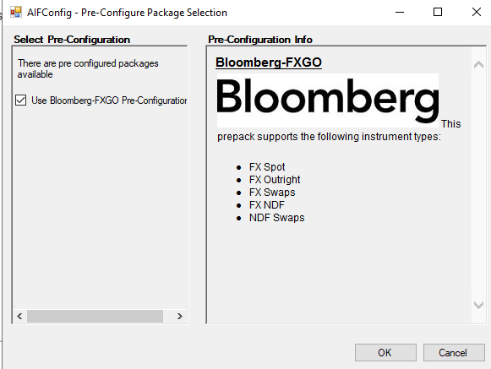

* 1. FIX Provider Details:

* 1. Click on Show Advanced:

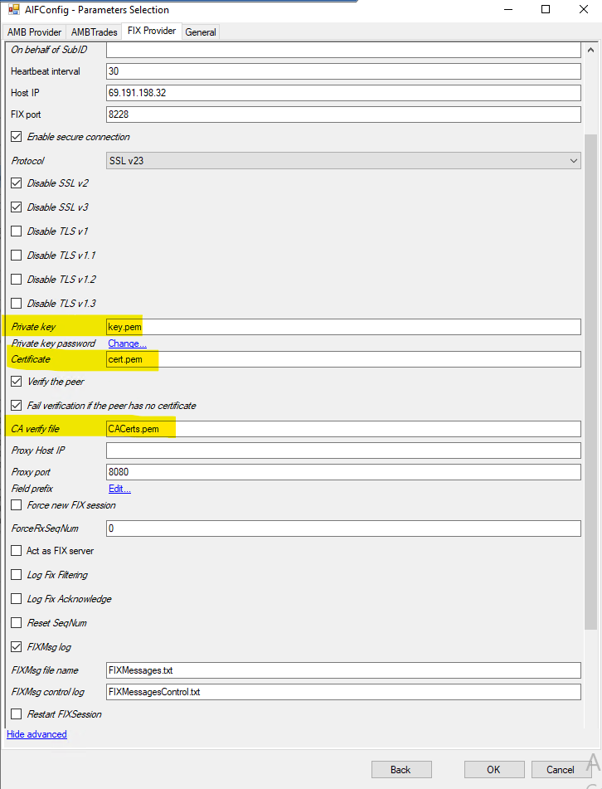

* 1. AMBTrades:

* 1. AMBProvider:

* 1. Once installed stop the AFG_AMB service.
  2. Go to **installed** directory of AFG_AMB …\Packages\AFG\FIXCommon\package.xml and change TLS setting as below:

* 1. Once installation is done copy **customisedFunctions.map, customisedInclude.map and FixDeviation.xml** file from **CMCS_Project_Mandiri\Deploy_1B\Project\Integrations\BBG\AFG-AMB Config\** **FXGO** to **Front\Front Arena\AFG_AMB\AFG_AMB_FIX_FXGO\customised**
  2. Start the AFG_AMB.
  3. AMBA will get installed with deployment tool.

1. **AFG_AMB_FIX_VCON:**

**Note:** DUMMY_UNDERLYING instrument must be present in FA. It will be created as a part of deployment process.

* 1. Download AFG_AMB and AFG_AMB Prepacks.
  2. Copy the Bloomberg-VCON FIT folder to AFG_AMB Setup folder for ex. C:\Projects\Installers\AFG_AMB\2022.4.0\Windows\PrePack.
  3. Run the AFG_AMBSetup.exe
  4. Click on Advance Option to name the instance as below

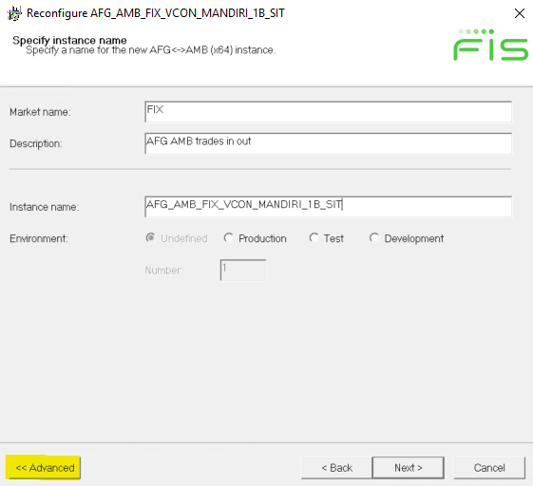

* 1. Select the prepack name in AIFConfig:

* 1. FIX Provider Details:

* 1. Click on Show Advanced:

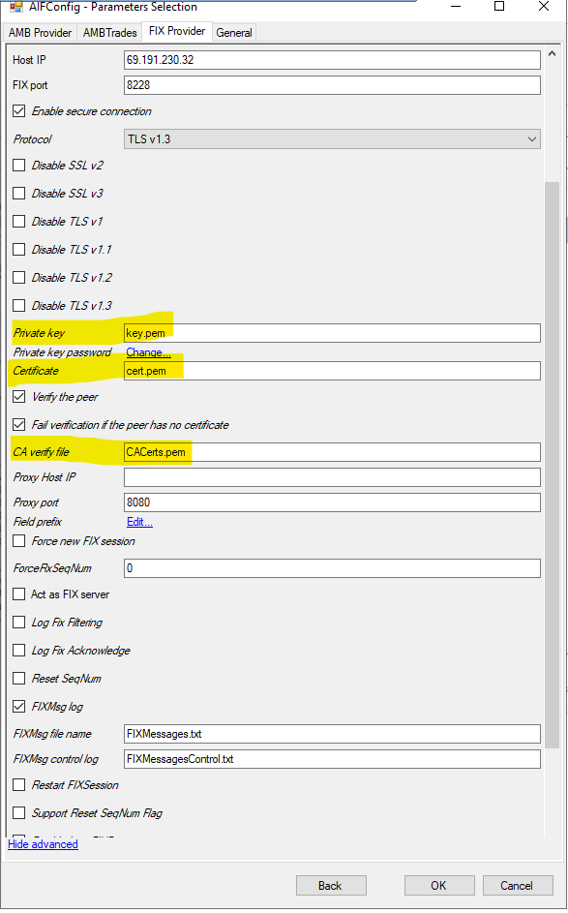

* 1. AMBTrades:

* 1. AMBProvider:

* 1. Once installed stop the AFG_AMB service.
  2. Go to **installed** directory of AFG_AMB …\Packages\AFG\FIXCommon\package.xml and change TLS setting as below:

* 1. Start the AFG_AMB service.
  2. AMBA will get installed with deployment tool.